**SIR APOLLO KAGGWA SCHOOLS**

**MID TERM II EXAMINATION 2024**

**PRIMARY SIX**

**SOCIAL STUDIES & RELIGIOUS EDUCATION**

***Time Allowed: 2hours 15 Minutes***

**Pupil’s Name: …………………………………………..……………………**

**Class: …………………………………….………………………………………**

**School Name: ………………………………………………………………….**

|  |  |  |
| --- | --- | --- |
| **FOR EXAMINERS’**  USE ONLY | | |
| **Qn. No.** | **MARKS** | **EXR’S**  **No.** |
| **1 - 10** |  |  |
| **11 – 20** |  |  |
| **21 – 30** |  |  |
| **31 – 40** |  |  |
| **41 – 43** |  |  |
| **44 – 46** |  |  |
| **47 – 49** |  |  |
| **50 - 52** |  |  |
| **53 - 55** |  |  |
| **TOTAL** |  |  |

**Read the following instructions carefully:**

1. This paper has two sections: **A** and **B**
2. Section **A** has 40 questions (40 marks)
3. Section **B** has 15 questions (50 marks)
4. Answer all questions. All the working for both sections A and B must be shown in the spaces provided.
5. All working must be done using a blue or black ball point pen or ink. Any work done in pencil will NOT be marked except drawings and diagram.
6. Unnecessary changes in your work and handwriting that cannot be easily read may lead to loss of marks.
7. Do not fill anything in the table indicated

**“For examiners’ use only”** and the boxes inside the question paper.

***Turn Over***

**SECTION A (40 Marks)**

1. Mention one cardinal point of a compass.

…………………………………………………………………………………………………………………

1. Which type of rainfall is mostly experienced around Lake Victoria?

………………………………………………………………………………………………………………….

1. Write down any one source of income for a school.

……………………………………………………………………………………………………………………

1. How many stanzas has the Uganda national anthem?

……………………………………………………………………………………………………………….…

1. Give one reason why newspapers are not commonly used for passing information.

…………………………………………………………………………………………………………………..

1. What do we call a raised flat topped piece of land?

………………………………………………………………………………………………………….………

1. Apart from shade, mention one other importance of trees on the school compound.

…………………………………………………………………………………………………………………

1. Give any one lake that forms a political boundary between Uganda and DRC?

…………………………………………………………………………………………………………………

1. How did HM Stanley contribute to the spread of Christianity in Uganda?

…………………………………………………………………………………………………………………

1. Give one way of promoting peace in a school.

………………………………………………………………………………………………………………….

1. Of what economic importance are waterfalls to the people of Uganda?

…………………………………………………………………………………………………………………

1. Give one reason why it is important for Uganda to cooperate with her neighbours.

……………………………………………………………………………………………………………………

1. Draw a map symbol for danger ahead in the space provided below.
2. What form of trade did Arab traders encourage in Uganda.

…………………………………………………………………………………………………………………..

1. Name one organ of EAC.

……………………………………………………………………………………………………………………

1. State one importance of electricity in homes.

……………………………………………………………………………………………………………………

1. Suggest one reason why some rivers in East Africa are not used for transport

.………………………………………………………………..…………………………………………………..

1. Give one duty of Uganda police force.

……………………………………………………………………………………………………………………

1. Identify any one perennial crop grown in East Africa.

……………………………………………………………………………………………………………………

1. Which type of climate is described as hot and dry throughout the year?

………………………………………………………………………………………………………………….

1. Which is the largest ethnic group of people in East Africa?

…………………………………………………………………………………………………………………..

1. Mention any one attribute of Uganda as a nation.

……………………………………………………………………………………………………………………

1. How did the work of Sir. Samuel Baker help the people of Northern Uganda?

.………………………………………………………………………………………………………………..

1. It is 4:00p.m at Greenwich Mean Time (GMT). What time will it be at a place 450W?

………………………………………………………………………………………………………………….

1. Identify one challenge facing Universal Primary Education Policy in Uganda.

………………………………………………………………………………………………………………….

1. Which river draws the largest volume of water from Lake Victoria?

……………………………………………………………………………………………………………………

1. What is child abuse?

……………………………………………………………………………………………………………………

1. Give any one reason why the Portuguese rule was not liked by the people at the coast of East Africa.

……………………………………………………………………………………………………..……………

1. Name the oldest interlacustrine kingdom in East Africa.

……………………………………………………………………………………………………………………

1. How did the 1900 Buganda agreement affect the people of Buganda?

…………………………………………………………………………………………………………………..

1. Identify any one characteristic of rift valley lakes.

………………………………………………………………………………………………………………….

1. Give one reason why the rain gauge is placed in an open place when used.

…………………………………………………………………………………………………………………

1. Why does the government carryout population census?

………………………………………………………………………………………………………………….

1. Name one Ugandan who struggled for independence from colonialists.

……………………………………………………………………………………………………………………

1. Why is Entebbe cooler than Dar-es-Salaam?

…………………………………………………………………………………………………………………

**For questions 36-40, answer only one part in a number. No mark will be given to a child who answers both parts either and or in a number.**

1. Either: How do Christians benefit from reading the Bible?

………………………………………………………………………………………………………………….

Or: How do Muslims benefit from reciting the Quran?

………………………………………………………………………………………………………………….

1. Either: In which town was Jesus born?

……………………………………………………………………………………………………………………

Or: In which town was Prophet Muhammad born?

……………………………………………………………………………………………………………………

1. Either: What does the word Genesis mean?

……………………………………………………………………………………………………………………

Or: Give the meaning of Hadith.

…………………………………………………………………………………………………………………..

1. Either: On which mountain did Noah’s Ark rest?

………………………………………………………………………………………………………………….

Or: On which mountain did Prophet Nuhur’s Ark rest?

…………………………………………………………………………………………………………………..

1. For both: What is fasting?

……………………………………………………………………………………………………………………

**SECTION B (60 MARKS).**

1. a) In which way have people misused forests?

……………………………………………………………………………………………………………………

b) Give two importance of forests to people?

(i)…………………………………………………………………………………………………………………

(ii)……………………………………………………………………………………………………………….

c) Identify one way forests are a danger to human life?

……………………………………………………………………………………………………………………

1. a) What is culture?

……………………………………………………………………………………………………………………

b) Identify any two cultural practices among the people of East Africa.

(i)………………………………………………………………………………………………………………..

(ii)………………………………………………………………………………………………………………..

c) How is culture important to people?

……………………………………………………………………………………………………………………

1. a) Which sea port handles imports and exports of Uganda?

………………………………………………………………………………………………………………….

b) Give the meaning of the word “exports”.

………………………………………………………………………………………………………………….

c) Name one inland port on

(i) L. Victoria : …………….……………………………………………………………………………

(ii) L. Albert: ……………………………………………………………………………………………

1. 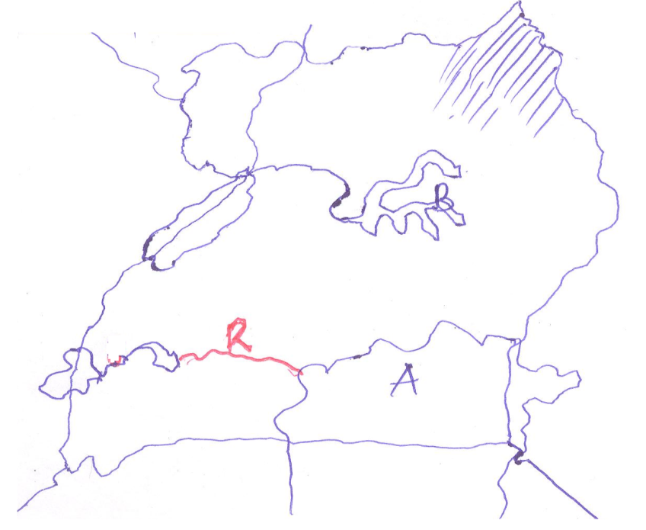**Study the map below and answer the following questions correctly.**
2. Give one similarity between Lake A and Lake B in terms of formation.

……………………………………………………………………………………………………………….

1. Name the river marked R.

……………………………………………………………………………………………………………….

1. What type of climate is experienced in the shaded region of the map?

………………………………………………………………………………………………………….

1. How does Lake A promote inter-territorial trade among the countries of East Africa?

……………………………………………………………………………………………………………..

1. a) What are luxury needs?

……………………………………………………………………………………………………………………

b) Give two examples of luxury needs of people.

(i)……………………………………………………………………………………………………………….

(ii)…………………………………………………………………………………………………………….

c) Why do people sometimes fail to get their luxury needs?

……………………………………………………………………………………………………………………

1. a) Write one importance of budgeting to a school.

………………………………………………………………………………………………………….………

b) Mention one type of taxes in Uganda.

…………………………………………………………………………………………………………………..

c) Identify any one part of a national budget,

……………………………………………………………………………………………………………………

d) Which body collects taxes for the government of Uganda?

……………………………………………………………………………………………………………………

1. a) Who was the first European explorer to arrive at the coast of East Africa in 1498?

………………………………………………………………………………………………………………….

b) Give one reason why explorers were interested in coming to Uganda.

……………………………………………………………………………………………………………………

c) Identify any two challenges faced by the European explorers in East Africa.

(i)…………………………………………………………………………………………………………….

(ii)…………………………………………………………………………………………………………….

1. a) What is population growth?

……………………………………………………………………………………………………………………

b) Identify any two factors that may lead to population growth in an area.

(i)………………………………………………………………………………………………………………..

(ii)………………………………………………………………………………………………………………

c) How can the government of Uganda control her ever increasing population?

……………………………………………………………………………………………………………………

1. a) Identify any two national game parks found in Uganda.

(i)…………………………………………………………………………………………………………………

(ii)………………………………………………………………………………………………………………..

b) State one economic importance of game parks.

……………………………………………………………………………………………………………………

c) Identify any one challenge facing national game parks in Uganda.

…………………………………………………………………………………………………………………..

1. **Match items in list A correctly to those in B.**

**A B**

1. Chief Awich represented central region in Legco in 1945
2. Milton Obote signed the 1956 Namirembe agreement for Britain.
3. Keith Hancock Uganda first executive prime minister.
4. Kawalya Kaggwa led the Lamogi rebellion.
5. Chief Awich…………………………………………………………..………………………………….
6. Milton Obote………………………………………………………..……………………………………
7. Keith Hancock……………………………………………………………………………………………
8. Kawalya Kaggwa………………………………………………………………………………………..

**For questions 51-55, answer either Christianity or Islam but not both in a number.**

1. Either: a) Who received the ten (10) commandments from God?

…………………………………………………………………………………………………………………..

b) What should a Christian do when he/she breaks any commandment?

…………………………………………………………………………………………………………………

c) Name the place where the commandments were given to the person in (a) above.

…………………………………………………………………………………………………………………

d) Name any one of the Ten (10) commandments of God.

………………………………………………………………………………………………………………….

Or: a) Who received the Holy Quran from Allah?

…………………………………………………………………………………………………………..………

b) Give one way Muslims show respect to the Quran.

……………………………………………………………………………………………………………………

c) Name the place where the Holy Quran was given to the person in (a) above.

………………………………………………………………………………………………………………….

d) Apart from the above book, name one other holy book in Islam.

……………………………………………………………………………………………………………………

1. Either: a) Which son of Adam killed his brother?

…………………………………………………………………………………………………………..………

b) Name the brother who was killed.

……………………………………………………………………………………………………………………

c) Why was the above brother you have named killed?

……………………………………………………………………………………………………………………

d) State one way in which God punished the above person.

…………………………………………………………………………………………………………………..

Or: a) Which son of Adam killed his brother?

……………………………………………………………………………………………………………………

b) Name the brother who was killed.

…………………………………………………………………………………………………………………

c) Why was the above brother you have named killed?

…………………………………………………………………………………………………………………..

d) State one way Allah punished the above person.

……………………………………………………………………………………………………………..……

1. Either: write short notes about;
2. Cana: ……………………..………………………………………………………………………………
3. Golgotha: ………………..………………………………………………………………………………
4. Gethsemane: ……………………………………………………………………………………………
5. Jerusalem: ………………….……………………………………………………………………………

**Or:** Write short notes about.

1. Kaaba: …………………..………………………………………………………………………………
2. Mecca: ………………….………………………………………………………………………………
3. Medina: …………………………………………………………………………………………………
4. Khadija: ………………….………………………………………………………………………………
5. Either: a) Who is a prophet according to the Bible?

…………………………………………………………………………………………………………………..

b) Give one role played by prophets in the Bible.

…………………………………………………………………………………………………………………..

c) Name two prophets in the Bible.

(i)……………………………………………………… (ii)……………………………………………………

Or: a) Who is a prophet according to Quran?

…………………………………………………………………………………………………………………..

b) Give one role played by prophets in the Quran

…………………………………………………………………………………………………………………..

c) Who was the;

(i) first prophet in Islam?………………………………………………………………………………

(ii) the last prophet in Islam? ………………………………………………………………………

1. For both: a) What is marriage?

………………………………………………………………………………………………………………….

b) Give one reason why people marry.

……………………………………………………………………………………………………………………

c) Write down any two qualities of a good marriage partner.

(i)………………………………………………………………………………………………………………

(ii)………………………………………………………………………………………………………………

***“GOOD LUCK”***